# **Junk File Organizer in Python**

* Difficulty Level : [Medium](https://www.geeksforgeeks.org/medium/)
* Last Updated : 10 Aug, 2021

Basically, as a lazy programmer, my desktop is full of files (Junk Files). Due to a large number of files, it is a daunting task to sit and organize each file. To make that task easy the below Python script comes in handy and all the files are organized in a well-manner within seconds.

**Screenshot before running the script**

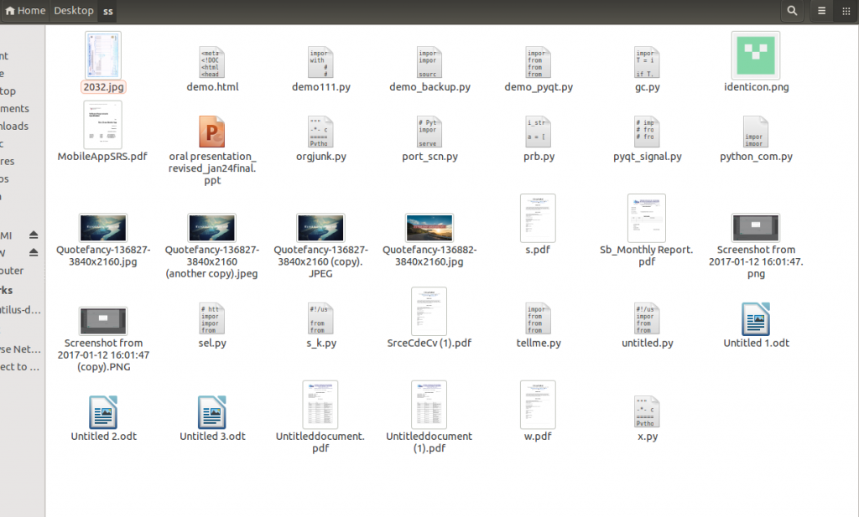

Following are the steps to be followed:

* **Create Dictionaries:** The code below will create the defined Directories.

DIRECTORIES = {

"HTML": [".html5", ".html", ".htm", ".xhtml"],

"IMAGES": [".jpeg", ".jpg", ".tiff", ".gif", ".bmp", ".png", ".bpg", "svg",

".heif", ".psd"],

"VIDEOS": [".avi", ".flv", ".wmv", ".mov", ".mp4", ".webm", ".vob", ".mng",

".qt", ".mpg", ".mpeg", ".3gp"],

"DOCUMENTS": [".oxps", ".epub", ".pages", ".docx", ".doc", ".fdf", ".ods",

".odt", ".pwi", ".xsn", ".xps", ".dotx", ".docm", ".dox",

".rvg", ".rtf", ".rtfd", ".wpd", ".xls", ".xlsx", ".ppt",

"pptx"],

"ARCHIVES": [".a", ".ar", ".cpio", ".iso", ".tar", ".gz", ".rz", ".7z",

".dmg", ".rar", ".xar", ".zip"],

"AUDIO": [".aac", ".aa", ".aac", ".dvf", ".m4a", ".m4b", ".m4p", ".mp3",

".msv", "ogg", "oga", ".raw", ".vox", ".wav", ".wma"],

"PLAINTEXT": [".txt", ".in", ".out"],

"PDF": [".pdf"],

"PYTHON": [".py"],

"XML": [".xml"],

"EXE": [".exe"],

"SHELL": [".sh"]

}

* **Mapping:** Now we will map the file formats with the directory.

FILE_FORMATS = {file_format: directory

for directory, file_formats in DIRECTORIES.items()

for file_format in file_formats}

* Here, we map file extensions with the directory.

def organize_junk():

for entry in os.scandir():

if entry.is_dir():

continue

file_path = Path(entry)

file_format = file_path.suffix.lower()

if file_format in FILE_FORMATS:

directory_path = Path(FILE_FORMATS[file_format])

directory_path.mkdir(exist_ok=True)

file_path.rename(directory_path.joinpath(file_path))

for dir in os.scandir():

try:

os.rmdir(dir)

except:

pass

* The above function will check for the existing directory for the same name we defined. If the existing directory is found then it will continue or else a new directory is created. And it will categorize all the files based on the extension in the appropriate folder.
* **Organizing:** Following is the code for Python Lazy Junk Files Organizer. It will organize everything in the appropriate folder in a single go and remove empty directories.
* python

| import os  from pathlib import Path    DIRECTORIES = {  "HTML": [".html5", ".html", ".htm", ".xhtml"],  "IMAGES": [".jpeg", ".jpg", ".tiff", ".gif", ".bmp", ".png", ".bpg", "svg",  ".heif", ".psd"],  "VIDEOS": [".avi", ".flv", ".wmv", ".mov", ".mp4", ".webm", ".vob", ".mng",  ".qt", ".mpg", ".mpeg", ".3gp"],  "DOCUMENTS": [".oxps", ".epub", ".pages", ".docx", ".doc", ".fdf", ".ods",  ".odt", ".pwi", ".xsn", ".xps", ".dotx", ".docm", ".dox",  ".rvg", ".rtf", ".rtfd", ".wpd", ".xls", ".xlsx", ".ppt",  "pptx"],  "ARCHIVES": [".a", ".ar", ".cpio", ".iso", ".tar", ".gz", ".rz", ".7z",  ".dmg", ".rar", ".xar", ".zip"],  "AUDIO": [".aac", ".aa", ".aac", ".dvf", ".m4a", ".m4b", ".m4p", ".mp3",  ".msv", "ogg", "oga", ".raw", ".vox", ".wav", ".wma"],  "PLAINTEXT": [".txt", ".in", ".out"],  "PDF": [".pdf"],  "PYTHON": [".py"],  "XML": [".xml"],  "EXE": [".exe"],  "SHELL": [".sh"]    }    FILE_FORMATS = {file_format: directory  for directory, file_formats in DIRECTORIES.items()  for file_format in file_formats}    def organize_junk():  for entry in os.scandir():  if entry.is_dir():  continue  file_path = Path(entry)  file_format = file_path.suffix.lower()  if file_format in FILE_FORMATS:  directory_path = Path(FILE_FORMATS[file_format])  directory_path.mkdir(exist_ok=True)  file_path.rename(directory_path.joinpath(file_path))    for dir in os.scandir():  try:  os.rmdir(dir)  except:  pass    if __name__ == "__main__":  organize_junk() |
| --- |

* Save the above script as [**orgjunk.py**](https://github.com/srcecde/lazy-junk-organizer). For example, you want to organize files at desktop then copy and paste the orgjunk.py at Desktop and run.

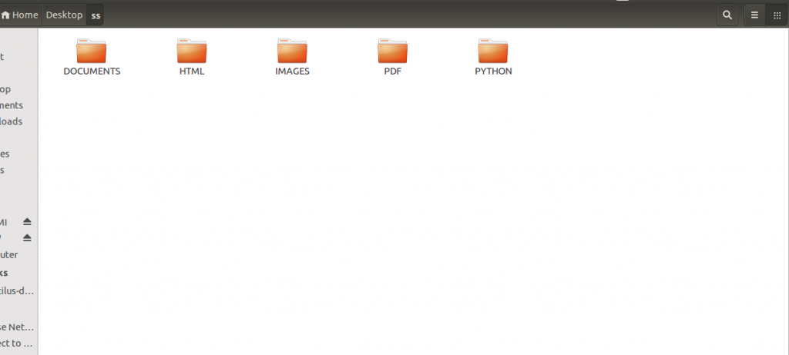

This article is contributed by [**Srce Cde**](https://twitter.com/srcecde). If you like GeeksforGeeks and would like to contribute, you can also write an article using contribute.geeksforgeeks.org or mail your article to contribute@geeksforgeeks.org. See your article appearing on the GeeksforGeeks main page and help other Geeks.

Please write comments if you find anything incorrect, or you want to share more information about the topic discussed above.